UNITED STATES

SECURITIES AND EXCHANGE COMMISSION
WASHINGTON, D.C. 20549

FORM 8-K

CURRENT REPORT

Pursuant to Section 13 or 15(d) of the Securities Exchange Act of 1934

Date of Report (Date of earliest event reported): May 14, 2026

REGENXBIO Inc.

(Exact name of Registrant as Specified in Its Charter)

Delaware | 001-37553 | 47-1851754
(State or Other Jurisdiction | (Commission File Number) | (IRS Employer
of Incorporation) |  | Identification No.)
9804 Medical Center Drive
Rockville, Maryland |  | 20850
(Address of Principal Executive Offices) |  | (Zip Code)

Registrant’s Telephone Number, Including Area Code: (240) 552-8181

N/A

(Former Name or Former Address, if Changed Since Last Report)

Check the appropriate box below if the Form 8-K filing is intended to simultaneously satisfy the filing obligation of the registrant under any of the following provisions:

- Written communications pursuant to Rule 425 under the Securities Act (17 CFR 230.425)

- Soliciting material pursuant to Rule 14a-12 under the Exchange Act (17 CFR 240.14a-12)

- Pre-commencement communications pursuant to Rule 14d-2(b) under the Exchange Act (17 CFR 240.14d-2(b))

- Pre-commencement communications pursuant to Rule 13e-4(c) under the Exchange Act (17 CFR 240.13e-4(c))

Securities registered pursuant to Section 12(b) of the Act:

 |  | Trading
Title of each class |  | Symbol(s) |  | Name of each exchange on which registered
Common Stock, par value $0.0001 per share |  | RGNX |  | The Nasdaq Global Select Market

Indicate by check mark whether the registrant is an emerging growth company as defined in Rule 405 of the Securities Act of 1933 (§ 230.405 of this chapter) or Rule 12b-2 of the Securities Exchange Act of 1934 (§ 240.12b-2 of this chapter).

Emerging growth company ☐

If an emerging growth company, indicate by check mark if the registrant has elected not to use the extended transition period for complying with any new or revised financial accounting standards provided pursuant to Section 13(a) of the Exchange Act. ☐

Item 2.02. Results of Operations and Financial Condition.

On May 14, 2026, REGENXBIO Inc. (the “Company”) issued a press release regarding its results of operations and financial condition for the quarter ended March 31, 2026. The press release is furnished as Exhibit 99.1 to this Current Report on Form 8‑K and is incorporated by reference herein.

The information in Item 2.02 of this Current Report on Form 8‑K and Exhibit 99.1 attached hereto shall not be deemed “filed” for purposes of Section 18 of the Securities Exchange Act of 1934, as amended (the “Exchange Act”), or otherwise subject to liability under that section, nor shall it be deemed incorporated by reference in any filing under the Securities Act of 1933, as amended, or the Exchange Act, except as expressly set forth by specific reference in such a filing.

Item 7.01. Regulation FD Disclosure.

On May 14, 2026, the Company presented topline and interim data analysis from the pivotal Phase III AFFINITY DUCHENNE® trial of RGX-202. A copy of the presentation materials is available on the “Presentations and Publications” section of the Company’s website at www.regenxbio.com.

The information in Item 7.01 of this Current Report on Form 8‑K and the presentation materials on the Company’s website shall not be deemed “filed” for purposes of Section 18 of the Securities Exchange Act of 1934, as amended (the “Exchange Act”), or otherwise subject to liability under that section, nor shall it be deemed incorporated by reference in any filing under the Securities Act of 1933, as amended, or the Exchange Act, except as expressly set forth by specific reference in such a filing.

Item 8.01. Other Events.

On May 14, 2026, the Company issued a press release announcing topline and interim analysis of data from the AFFINITY DUCHENNE RGX-202 trial (the “RGX-202 Press Release”). A copy of the RGX-202 Press Release is furnished as Exhibit 99.2 to this Current Report on Form 8-K and is incorporated by reference herein.

Item 9.01. Financial Statements and Exhibits.

- Exhibits

Exhibit No. |  | Description
99.1 |  | Press release dated May 14, 2026 relating to REGENXBIO Inc.’s financial results.
99.2 |  | RGX-202 Press Release dated May 14, 2026.

- The cover page from this Current Report on Form 8-K, formatted in Inline XBRL.

SIGNATURES

Pursuant to the requirements of the Securities Exchange Act of 1934, the registrant has duly caused this report to be signed on its behalf by the undersigned hereunto duly authorized.

REGENXBIO INC.

Date: May 14, 2026 By: /s/ Patrick J. Christmas II

Patrick J. Christmas II

Executive Vice President, Chief Strategy & Legal Officer

EXHIBIT 99.1


REGENXBIO Reports First Quarter 2026 Financial Results and Operational Highlights

- Company announced positive topline results from pivotal Phase III AFFINITY DUCHENNE® study of RGX-202 o Primary endpoint achieved with high statistical significance

o Statistically significant correlation between RGX-202 microdystrophin expression and functional improvement (NSAA, n=9), supporting validity of surrogate endpoint
- Surabgene lomparvovec (sura-vec, ABBV-RGX-314) on track toward key catalysts
  - Sites activated in pivotal Phase IIb/III study for diabetic retinopathy; first patient dosed expected Q2 2026
  - Subretinal wet AMD topline pivotal data expected in Q4 2026
- Clinical hold lifted for RGX-121
- Webcast today at 8:00 a.m. ET to discuss RGX-202 topline pivotal data and Q1 2026 earnings

ROCKVILLE, Md., May 14, 2026 (PR Newswire) -- REGENXBIO Inc. (Nasdaq: RGNX) today reported financial results and operational highlights for the first quarter ended March 31, 2026.

“REGENXBIO enters a transformative year with positive momentum, reaching significant late-stage milestones to support our potential first- and best-in-class gene therapies,” said Curran Simpson, President and Chief Executive Officer, REGENXBIO. “On our mission to bring meaningful new therapies to rare disease communities facing limited options, we remain focused on advancing RGX-202 for Duchenne toward potential BLA submission and are excited to share topline pivotal data in our webcast today; we also continue engaging with the FDA regarding a potential path forward for RGX-121 for Hunter syndrome. In chronic retinal diseases, we are executing against our multi-indication strategy and preparing for the Phase 3 wet AMD readout with partner AbbVie. Additionally, we continue harnessing internal manufacturing capabilities to support anticipated commercial needs. We remain well-positioned to capitalize on several near-term, high-value opportunities and bring these highly differentiated treatments to patients.”

PROGRAM HIGHLIGHTS AND MILESTONES

Neuromuscular Disease: RGX-202 is a potential best-in-class gene therapy for Duchenne muscular dystrophy (Duchenne). RGX-202 is designed to address the underlying cause of Duchenne by enabling targeted expression of a novel microdystrophin that is closest to naturally occurring dystrophin. It is the only microdystrophin that includes the C-Terminal domain, which has been shown to protect and preserve muscle function. The differentiated therapeutic approach behind RGX-202 includes a novel construct, a proactive immune suppression regimen, and a suspension-based manufacturing process that delivers industry-leading product purity levels. RGX-202 is designed for improved muscle function, durability and positive safety outcomes and is being evaluated in the Phase I/II/III AFFINITY DUCHENNE® trial in ambulatory patients aged 1+.

- REGENXBIO today announced positive topline results from the pivotal Phase III AFFINITY DUCHENNE trial of RGX-202, including primary endpoint (n=30 at Week 12), interim safety (n=31), and interim functional data (n=9 at 12 months):¹
o Achieved primary endpoint with high statistical significance; 93% of patients achieved RGX-202 microdystrophin expression above 10% (p<0.0001)

o RGX-202 was well-tolerated, continued to demonstrate a favorable interim safety profile.
- Statistically significant correlation between RGX-202 microdystrophin expression level and functional improvement (NSAA, n=9), supporting the validity of the surrogate endpoint.
- More than 20 additional participants have been enrolled in the confirmatory trial of RGX-202 (n=30), and the Company expects to have completed dosing in all 60 patients across the pivotal and confirmatory trials by mid-year.
- REGENXBIO continues to manufacture intended commercial supply of RGX-202 at its in-house Manufacturing Innovation Center.
- Topline data supports plans for potential accelerated approval in 2027.

Retinal Disease: Surabgene lomparvovec (sura-vec, ABBV-RGX-314), developed in collaboration with AbbVie, is potentially the first-in-class gene therapy treatment for wet age-related macular degeneration (wet AMD) and diabetic retinopathy (DR).

Sura-vec for the Treatment of Wet AMD (Subretinal Delivery)

- REGENXBIO expects to share topline data with AbbVie from ATMOSPHERE® and ASCENT® pivotal trials of sura-vec using subretinal delivery in Q4 2026.

- Global regulatory submissions are expected in 2027.

Sura-vec for the Treatment of DR (Suprachoroidal Delivery)

- U.S. clinical sites are active and initiating enrollment in the Phase IIb/III NAAVIGATE study. NAAVIGATE is a Phase IIb/III multicenter, randomized, masked, sham-controlled study to evaluate the safety and efficacy of sura-vec in subjects with non-proliferative DR (NPDR) without center-involved diabetic macular edema (CI-DME).
- REGENXBIO will receive a $100 million milestone payment from AbbVie upon first patient dosed in the Phase IIb portion of NAAVIGATE, expected in Q2 2026.

Sura-vec for the Treatment of Wet AMD (Suprachoroidal Delivery)

- Enrollment is complete in the Phase II AAVIATE® trial.

Neurodegenerative Disease: Clemidsogene lanparvovec (RGX-121) is a potential first-in-class treatment for Mucopolysaccharidosis (MPS) Type II, also known as Hunter syndrome. RGX-111 is an investigational one-time treatment for severe MPS I, also known as Hurler syndrome. These programs are partnered with Nippon Shinyaku.
- The FDA has lifted the partial clinical hold on RGX-121.
- REGENXBIO recently filed an appeal of the 121 CRL and is continuing to engage the agency regarding a path forward for the program.

- 30 of 31 total participants have Week 12 biopsy available for evaluation; one participant refused muscle biopsy.

FINANCIAL RESULTS

Cash Position: Cash, cash equivalents and marketable securities were $150.5 million as of March 31, 2026, compared to $240.9 million as of December 31, 2025. The decrease was primarily driven by cash used to fund operating activities during the first quarter of 2026. Cash used in operations in the first quarter of 2026 included a non-recurring payment of $10.0 million under a previously announced settlement agreement with GlaxoSmithKline in March 2026, and is otherwise generally consistent with historical first quarter cash spend.

Revenues: Revenues were $6.4 million for the three months ended March 31, 2026, compared to $89.0 million for the three months ended March 31, 2025. The decrease was primarily attributable to $70.0 million of upfront license recognized under the collaboration with Nippon Shinyaku in the first quarter of 2025, as well as a $12.2 million decrease in ZOLGENSMA® royalty revenues due to the expiration of licensed patents in the U.S. in January 2026. Novartis launched U.S. sales of ITVISMA® in the first quarter of 2026. REGENXBIO is entitled to royalties on certain net sales of ITVISMA in the U.S. and other jurisdictions with patents extending until 2037.

Research and Development (R&D) Expenses: R&D expenses were $57.3 million for the three months ended March 31, 2026 compared to $53.1 million for the three months ended March 31, 2025. The increase was primarily attributable to clinical trial expenses for RGX-202 and personnel-related costs.

General and Administrative Expenses: General and administrative expenses were $21.3 million for the three months ended March 31, 2026 compared to $20.3 million for the three months ended March 31, 2025. The increase was largely driven by personnel-related costs, consulting and corporate advisory services.

Net Income: Net loss was $90.1 million, or $1.72 basic and diluted net loss per share, for the three months ended March 31, 2026, compared to net income of $6.1 million, or $0.12 basic and diluted net income per share, for the three months ended March 31, 2025.

FINANCIAL GUIDANCE

REGENXBIO expects its balance in cash, cash equivalents and marketable securities of $150.5 million as of March 31, 2026 to fund its operations into early 2027. This cash runway guidance is based on the Company’s current operational plans and excludes the impact of any material payments that may potentially be received from partners or licensees upon the achievement of development or regulatory milestones, or upon the approval or commercialization of product candidates, and excludes any additional potential dilutive or non-dilutive funding opportunities.

CONFERENCE CALL

REGENXBIO will host a conference call and webcast at 8:00 a.m. ET today to discuss the RGX-202 topline data as well as first quarter 2026 updates. The live webcast can be accessed here and in the Investor section of REGENXBIO's website at www.regenxbio.com. An archived replay of the webcast will be available for approximately 30 days following the presentation.

ABOUT REGENXBIO Inc.

REGENXBIO is a biotechnology company on a mission to improve lives through the curative potential of gene therapy. Since its founding in 2009, REGENXBIO has pioneered the field of AAV gene therapy. REGENXBIO is advancing a late-stage pipeline of one-time treatments for rare and retinal diseases, including RGX-202 for the treatment of Duchenne; clemidsogene lanparvovec (RGX-121) for the treatment of MPS II and RGX-111 for the treatment of MPS I,

both in partnership with Nippon Shinyaku; and surabgene lomparvovec (ABBV-RGX-314) for the treatment of wet AMD and diabetic retinopathy, in collaboration with AbbVie. Thousands of patients have been treated with REGENXBIO's AAV platform, including those receiving Novartis' ZOLGENSMA. REGENXBIO's investigational gene therapies have the potential to change the way healthcare is delivered for millions of people. For more information, please visit www.REGENXBIO.com.

FORWARD-LOOKING STATEMENTS

This press release includes "forward-looking statements," within the meaning of Section 27A of the Securities Act of 1933, as amended, and Section 21E of the Securities Exchange Act of 1934, as amended. These statements express a belief, expectation or intention and are generally accompanied by words that convey projected future events or outcomes such as "believe," "may," "will," "estimate," "continue," "anticipate," "assume," "design," "intend," "expect," "could," "plan," "potential," "predict," "seek," "should," "would" or by variations of such words or by similar expressions. The forward-looking statements include statements relating to, among other things, REGENXBIO's future operations, clinical trials, costs and cash flow. REGENXBIO has based these forward-looking statements on its current expectations and assumptions and analyses made by REGENXBIO in light of its experience and its perception of historical trends, current conditions and expected future developments, as well as other factors REGENXBIO believes are appropriate under the circumstances. However, whether actual results and developments will conform with REGENXBIO's expectations and predictions is subject to a number of risks and uncertainties, including the timing of enrollment, commencement and completion and the success of clinical trials conducted by REGENXBIO, its licensees and its partners, the timing of commencement and completion and the success of preclinical studies conducted by REGENXBIO and its development partners, the timing or likelihood of payments from AbbVie or Nippon Shinyaku, the monetization of any priority review voucher, the timely development and launch of new products, the ability to obtain and maintain regulatory approval of product candidates, the ability to obtain and maintain intellectual property protection for product candidates and technology, trends and challenges in the business and markets in which REGENXBIO operates, the size and growth of potential markets for product candidates and the ability to serve those markets, the rate and degree of acceptance of product candidates, and other factors, many of which are beyond the control of REGENXBIO. Refer to the "Risk Factors" and "Management's Discussion and Analysis of Financial Condition and Results of Operations" sections of REGENXBIO's Annual Report on Form 10-K for the year ended December 31, 2025, filed with the U.S. Securities and Exchange Commission (SEC) and comparable "risk factors" sections of REGENXBIO's Quarterly Reports on Form 10-Q and other filings, which have been filed with the SEC and are available on the SEC's website at WWW.SEC.GOV. All of the forward-looking statements made in this press release are expressly qualified by the cautionary statements contained or referred to herein. The actual results or developments anticipated may not be realized or, even if substantially realized, they may not have the expected consequences to or effects on REGENXBIO or its businesses or operations. Such statements are not guarantees of future performance and actual results or developments may differ materially from those projected in the forward-looking statements. Readers are cautioned not to rely too heavily on the forward-looking statements contained in this press release. These forward-looking statements speak only as of the date of this press release. Except as required by law, REGENXBIO does not undertake any obligation, and specifically declines any obligation, to update or revise any forward-looking statements, whether as a result of new information, future events or otherwise.

Zolgensma® and Itvisma® are registered trademarks of Novartis Gene Therapies. All other trademarks referenced herein are registered trademarks of REGENXBIO.

CONTACTS:
Dana Cormack
Corporate Communications
Dcormack@regenxbio.com

George E. MacDougall
Investor Relations

IR@regenxbio.com

REGENXBIO INC.

CONSOLIDATED BALANCE SHEETS
(unaudited)

(in thousands)

 |  |  | March 31, 2026 |  |  | December 31, 2025
Assets
Current assets
Cash and cash equivalents | $ |  | 15,229 |  | $ | 34,466
Marketable securities |  |  | 135,262 |  |  | 195,604
Accounts receivable |  |  | 10,038 |  |  | 26,379
Prepaid expenses |  |  | 11,543 |  |  | 11,927
Other current assets |  |  | 14,444 |  |  | 12,905
Total current assets |  |  | 186,516 |  |  | 281,281
Marketable securities |  |  | — |  |  | 10,785
Accounts receivable |  |  | 420 |  |  | 2,312
Property and equipment, net |  |  | 101,874 |  |  | 104,855
Operating lease right-of-use assets |  |  | 45,541 |  |  | 47,156
Restricted cash |  |  | 2,030 |  |  | 2,030
Other assets |  |  | 5,513 |  |  | 4,613
Total assets | $ |  | 341,894 |  | $ | 453,032
Liabilities and Stockholders’ Equity
Current liabilities
Accounts payable | $ |  | 21,207 |  | $ | 21,358
Accrued expenses and other current liabilities |  |  | 21,892 |  |  | 38,390
Deferred revenue |  |  | 5,919 |  |  | 10,452
Operating lease liabilities |  |  | 7,867 |  |  | 8,286
Royalty monetization liabilities |  |  | 14,225 |  |  | 39,609
Total current liabilities |  |  | 71,110 |  |  | 118,095
Deferred revenue |  |  | 22,776 |  |  | 18,943
Operating lease liabilities |  |  | 63,199 |  |  | 65,215
Royalty monetization liabilities |  |  | 163,105 |  |  | 147,408
Other liabilities |  |  | 622 |  |  | 638
Total liabilities |  |  | 320,812 |  |  | 350,299
Stockholders’ equity
Preferred stock; no shares issued and outstanding
at March 31, 2026 and December 31, 2025 |  |  | — |  |  | —
Common stock; 51,617 and 50,892 shares issued
and outstanding at March 31, 2026 and
December 31, 2025, respectively |  |  | 5 |  |  | 5
Additional paid-in capital |  |  | 1,238,025 |  |  | 1,229,442
Accumulated other comprehensive loss |  |  | (870) |  |  | (687)
Accumulated deficit |  |  | (1,216,078) |  |  | (1,126,027)
Total stockholders’ equity |  |  | 21,082 |  |  | 102,733
Total liabilities and stockholders’ equity | $ |  | 341,894 |  | $ | 453,032

REGENXBIO INC.

CONSOLIDATED STATEMENTS OF OPERATIONS AND COMPREHENSIVE INCOME (LOSS)
(unaudited)

(in thousands, except per share data)

 | Three Months Ended March 31,
 | 2026 |  |  | 2025
Revenues
License and royalty revenue | $ | 5,090 |  | $ |  | 87,049
Service revenue |  | 1,303 |  |  |  | 1,963
Total revenues |  | 6,393 |  |  |  | 89,012
Operating Expenses
Cost of license and royalty revenues |  | 11,074 |  |  |  | 3,436
Research and development |  | 57,339 |  |  |  | 53,087
General and administrative |  | 21,306 |  |  |  | 20,347
Other operating expenses |  | 36 |  |  |  | 15
Total operating expenses |  | 89,755 |  |  |  | 76,885
Income (loss) from operations |  | (83,362) |  |  |  | 12,127
Other Income (Expense)
Interest income from licensing |  | 16 |  |  |  | 25
Investment income |  | 2,003 |  |  |  | 2,501
Interest expense |  | (8,708) |  |  |  | (8,570)
Total other income (expense) |  | (6,689) |  |  |  | (6,044)
Net income (loss) | $ | (90,051) |  | $ |  | 6,083
Other Comprehensive Loss
Unrealized loss on available-for-sale securities, net |  | (183) |  |  |  | (21)
Total other comprehensive loss |  | (183) |  |  |  | (21)
Comprehensive income (loss) | $ | (90,234) |  | $ |  | 6,062
Net income (loss) per share:
Basic | $ | (1.72) |  | $ |  | 0.12
Diluted | $ | (1.72) |  | $ |  | 0.12
Weighted-average common shares outstanding:
Basic |  | 52,428 |  |  |  | 51,362
Diluted |  | 52,428 |  |  |  | 51,434

###

EXHIBIT 99.2


REGENXBIO Announces Positive Topline Results from Pivotal Phase III AFFINITY DUCHENNE® Study of RGX-202

- Achieved primary endpoint with high statistical significance; 93% of patients achieved microdystrophin expression above 10% (p<0.0001)
- Statistically significant correlation between RGX-202 microdystrophin expression and functional improvement (NSAA n=9), supporting validity of surrogate endpoint

- Well-tolerated, differentiated safety profile
- Company preparing for potential accelerated approval in 2027
- Webcast to be held at 8:00 a.m. ET today

ROCKVILLE, Md., May 14, 2026 /PRNewswire/ -- REGENXBIO Inc. (Nasdaq: RGNX) announced positive topline and interim functional data from the pivotal Phase III portion of the Phase I/II/III AFFINITY DUCHENNE® trial of RGX-202, a potential best-in-class gene therapy for Duchenne Muscular Dystrophy. The trial met its primary endpoint with high statistical significance (p<0.0001), with 93% of participants reaching at least 10% microdystrophin expression at Week 12 (n=30). Additionally, RGX-202 demonstrated statistically significant correlation between microdystrophin expression and interim functional improvement.

“These topline results are exciting for the Duchenne community,” said Pat Furlong, Founding President of Parent Project for Muscular Dystrophy. “For decades, our community has pushed for therapies that can change the trajectory of this disease, and today’s news gives us renewed optimism. Our families cannot wait; regulatory flexibility for innovative medicines to treat rare disease remains an urgent priority. We applaud the dedication of the patients and families who participated in this research and look forward to continued progress toward delivering stronger futures for people with Duchenne.”

“Duchenne muscular dystrophy is a rare, progressive neuromuscular disease characterized by worsening muscle weakness and loss of function, and there continues to be a critical unmet need for therapies that can reliably alter the course of the disease”, said AFFINITY DUCHENNE principal investigator Aravindhan Veerapandiyan, M.D., Arkansas Children’s Hospital. “It’s encouraging to see robust microdystrophin expression, correlation with functional outcomes, and a manageable safety profile. These data give us hope and reinforce the potential of RGX-202 to positively impact disease progression in individuals with Duchenne."

“RGX-202 is the first gene therapy in development for Duchenne to demonstrate strong, statistically significant correlation between microdystrophin expression and functional improvement, a landmark distinction in the field,” said Steve Pakola, M.D., Chief Medical Officer of REGENXBIO. “Today’s topline results underscore how our novel construct and differentiated therapeutic approach support a favorable safety profile and potential clinical benefit, including in older patients where progressive decline is expected. These data support the potential of RGX-202 to become a best-in-class gene therapy for Duchenne patients.”

AFFINITY DUCHENNE Topline Pivotal Interim Data

As of April 16, 2026

The pivotal portion of the Phase I/II/III AFFINITY DUCHENNE trial evaluated RGX-202 at 2x10¹⁴ GC/kg in 31 ambulatory boys aged 1 year of age and older. Key topline interim results include safety (n=31), biomarker (n=30), and functional data (n=9 aged >4 years, 12 months post-treatment).¹

More than 20 additional participants have been enrolled in the confirmatory trial of RGX-202 (n=30), and the Company expects to have completed dosing in all 60 patients across the pivotal and confirmatory trials by mid-year.

Primary Endpoint and Biomarker Data

93% of participants achieved >10% RGX-202 microdystrophin expression at Week 12 (p<0.0001). Microdystrophin expression averaged 71.1% across all participants, and 41.6% in older boys, aged >8 years. Additionally, 80% of participants achieved >40% microdystrophin expression.

RGX-202 was appropriately localized to the sarcolemma, demonstrating that the differentiated construct with the inclusion of the C-Terminal (CT) domain is appropriately targeting the muscle. Additionally, robust vector copies per nucleus and percent positive fibers observed support the potential for sustained microdystrophin expression.

Interim Safety and Tolerability Data

RGX-202 was well tolerated and demonstrated a favorable safety profile as of last data cut. A proactive, short-course immune suppression regimen in combination with a differentiated construct and industry-leading product purity levels of more than 80% full capsids may contribute to a favorable safety profile for RGX-202. Mean gamma-glutamyl transferase (GGT) and total bilirubin, recognized markers of liver inflammation in Duchenne, did not exceed the upper limit of normal up to one year post-treatment (n=9).

Two serious adverse events were reported; both were easily managed and resolved within weeks without sequelae. One case of subacute myocarditis was reported in an 8-year-old participant. The participant’s most recent cardiac MRI confirmed no heart muscle fibrosis and no change in ejection fraction. One case of asymptomatic liver injury was reported in a 10-year-old participant. This patient’s GGT peak elevation was 123 U/L, and his abdominal ultrasound and bilirubin levels were normal. Common drug-related adverse events included vomiting, fatigue, and nausea, all considered mild or moderate, and resolved without sequelae.

Interim One Year Functional Data

In interim functional results from nine participants aged approximately 5 to 12 years at dosing, RGX-202 demonstrated functional improvement and evidence of positively impacting disease trajectory at one year post-treatment, as measured by North Star Ambulatory Assessment (NSAA) and timed function tests (Time to Stand, 10 Meter Walk-run, Time to Climb).

Participants demonstrated statistically significant improved performance across NSAA and all timed function tests when compared to external control using propensity score weighting, which is the primary analysis method specified in the SAP for the pivotal trial. [Figure 1]

- 30 of 31 total participants have Week 12 biopsy available for evaluation; one participant refused muscle biopsy.

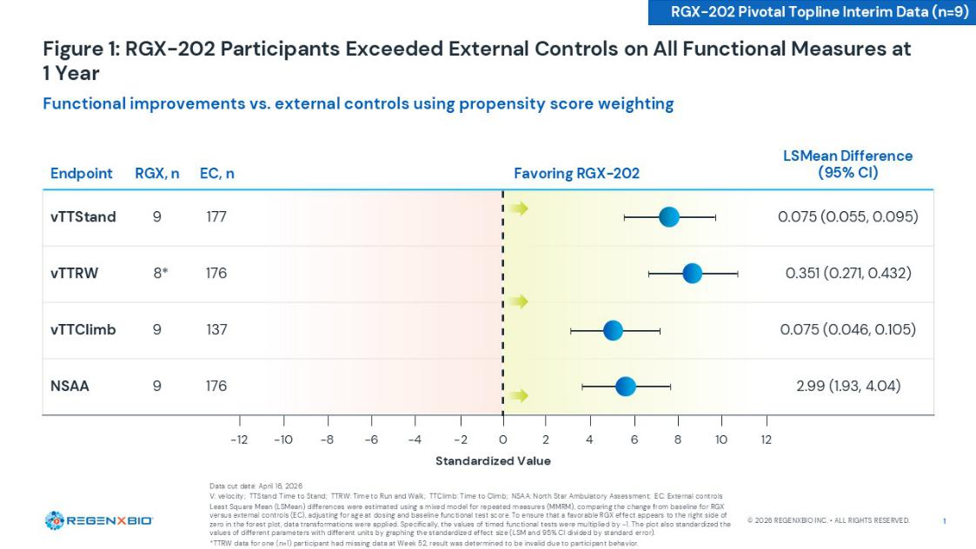

RGX-202 microdystrophin expression at Week 12 demonstrated a statistically significant correlation with functional improvement at one year as measured by NSAA change from baseline (correlation= .094, p = 0.0002) and NSAA change from baseline compared to the cTAP predictive model (correlation= .092, p = 0.0005). [Figure 2]
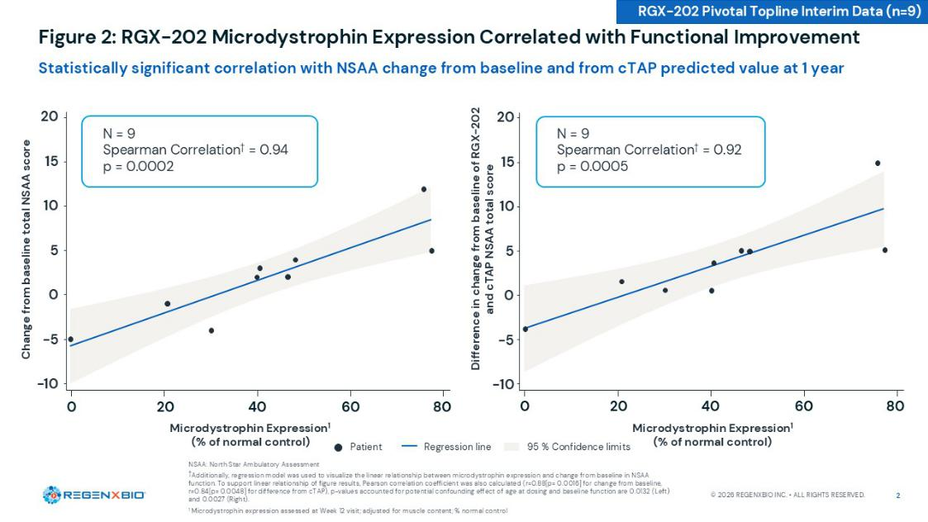

Primary Endpoint and Interim Data Support Potential Accelerated Approval

In recent discussions with FDA, the agency shared that the use of RGX-202 microdystrophin expression as a surrogate endpoint will be based on the correlation analysis with clinical outcomes, which has been clearly demonstrated in the interim data. While the FDA has recommended a randomized controlled trial, it has guided that externally controlled trials may be adequate for demonstrating substantial evidence of effectiveness, especially when the treatment effect is sufficiently large enough to overcome limitations of externally controlled trials. FDA offered to review the RGX-202 data and alternative proposals. REGENXBIO plans to discuss this data with the FDA at a future meeting. The Company is also finalizing the trial design for an ex-U.S. study to support global regulatory submissions.

Given the positive topline pivotal data, continued favorable safety profile, and statistically significant correlation between microdystrophin and functional improvement, REGENXBIO plans to pursue accelerated approval for RGX-202 and is preparing for a potential commercial launch in 2027.

Webcast Details

REGENXBIO will host a webcast featuring REGENXBIO management and leading Duchenne physicians Dr. Veerapandiyan, Carolina Tesi-Rocha, M.D., Clinical Professor, Neurology, Stanford School of Medicine, Stanford Children's Health, and Diana Castro, M.D., Founder and Director of the Neurology & Neuromuscular Care Center and Neurology Rare Disease Center, to discuss today's developments at 8:00 a.m. ET.

The live webcast can be accessed HERE and in the Investors section of REGENXBIO's website at WWW.REGENXBIO.COM.

An archived replay of the webcast will be available for approximately 30 days following the presentation.

About RGX-202 RGX-202 is designed to address the underlying cause of Duchenne by enabling targeted expression of a novel microdystrophin that is closest to naturally occurring dystrophin. It is the only microdystrophin that includes the C-Terminal domain, which has been shown to protect and preserve muscle function. The differentiated therapeutic approach behind RGX-202 includes a novel construct, a proactive immune suppression regimen, and a suspension-based manufacturing process that delivers industry-leading product purity levels. RGX-202 is designed for improved muscle function, durability and safety outcomes for patients.

About Duchenne Muscular Dystrophy

Duchenne is a severe, progressive, degenerative muscle disease, affecting 1 in 3,500 to 5,000 boys born each year worldwide. Duchenne is caused by mutations in the Duchenne gene which encodes for dystrophin, a protein involved in muscle cell structure and signaling pathways. Without dystrophin, muscles throughout the body degenerate and become weak, eventually leading to loss of movement and independence, required support for breathing, cardiomyopathy and premature death.

About REGENXBIO Inc.

REGENXBIO is a biotechnology company on a mission to improve lives through the curative potential of gene therapy. Since its founding in 2009, REGENXBIO has pioneered the field of AAV gene therapy. REGENXBIO is advancing a late-stage pipeline of one-time treatments for rare and retinal diseases, including RGX-202 for the treatment of Duchenne; clemidsogene lanparvovec (RGX-121) for the treatment of MPS II and RGX-111 for the treatment of MPS I,

both in partnership with Nippon Shinyaku; and surabgene lomparvovec (ABBV-RGX-314) for the treatment of wet AMD and diabetic retinopathy, in collaboration with AbbVie. Thousands of patients have been treated with REGENXBIO's AAV platform, including those receiving Novartis' ZOLGENSMA®. REGENXBIO's investigational gene therapies have the potential to change the way healthcare is delivered for millions of people. For more information, please visit www.regenxbio.com.

FORWARD-LOOKING STATEMENTS

This press release includes "forward-looking statements," within the meaning of Section 27A of the Securities Act of 1933, as amended, and Section 21E of the Securities Exchange Act of 1934, as amended. These statements express a belief, expectation or intention and are generally accompanied by words that convey projected future events or outcomes such as "believe," "may," "will," "estimate," "continue," "anticipate," "assume," "design," "intend," "expect," "could," "plan," "potential," "predict," "seek," "should," "would" or by variations of such words or by similar expressions. The forward-looking statements include statements relating to, among other things, REGENXBIO's future operations and clinical trials, the timing, availability and interpretation of clinical data, including interim, preliminary or updated data readouts. REGENXBIO has based these forward-looking statements on its current expectations and assumptions and analyses made by REGENXBIO in light of its experience and its perception of historical trends, current conditions and expected future developments, as well as other factors REGENXBIO believes are appropriate under the circumstances. However, whether actual results and developments will conform with REGENXBIO's expectations and predictions is subject to a number of risks and uncertainties, including risks related to the availability, timing, completeness and interpretation of clinical and preclinical data; the possibility that interim, preliminary or early data may not be indicative of final results; that additional data, longer follow-up or subsequent analyses may materially change previously reported results; and that regulatory authorities may interpret data differently than the REGENXBIO, the timing of enrollment, commencement and completion and the success of clinical trials conducted by REGENXBIO, its licensees and its partners, the timely development and launch of new products, the ability to obtain and maintain regulatory approval of product candidates, the ability to obtain and maintain intellectual property protection for product candidates and technology, trends and challenges in the business and markets in which REGENXBIO operates, the size and growth of potential markets for product candidates and the ability to serve those markets, the rate and degree of acceptance of product candidates, and other factors, many of which are beyond the control of REGENXBIO. Refer to the "Risk Factors" and "Management's Discussion and Analysis of Financial Condition and Results of Operations" sections of REGENXBIO's Annual Report on Form 10-K for the year ended December 31, 2025, and comparable "risk factors" sections of REGENXBIO's Quarterly Reports on Form 10-Q and other filings, which have been filed with the SEC and are available on the SEC's website at WWW.SEC.GOV. All of the forward-looking statements made in this press release are expressly qualified by the cautionary statements contained or referred to herein. The actual results or developments anticipated may not be realized or, even if substantially realized, they may not have the expected consequences to or effects on REGENXBIO or its businesses or operations. Such statements are not guarantees of future performance and actual results or developments may differ materially from those projected in the forward-looking statements. Readers are cautioned not to rely too heavily on the forward-looking statements contained in this press release. These forward-looking statements speak only as of the date of this press release. Except as required

by law, REGENXBIO does not undertake any obligation, and specifically declines any obligation, to update or revise any forward-looking statements, whether as a result of new information, future events or otherwise.

Zolgensma® is a registered trademark of Novartis AG. All other trademarks referenced herein are registered trademarks of REGENXBIO.

Contacts:
Dana Cormack
Corporate Communications
dcormack@regenxbio.com

Investors:
George E. MacDougall
Investor Relations
IR@regenxbio.com

