UNITED STATES

SECURITIES AND EXCHANGE COMMISSION
Washington, D.C. 20549

FORM 8-K

Current Report

Pursuant to Section 13 or 15(d)
of the Securities Exchange Act of 1934

Date of Report (Date of earliest event reported): October 11, 2019

REGENXBIO Inc.

(Exact Name of Registrant as Specified in its Charter)

Delaware | 001-37553 | 47-1851754
(State or other jurisdiction | (Commission | (I.R.S. Employer
of incorporation) | File Number) | Identification No.)
9600 Blackwell Road, Suite 210
Rockville, Maryland |  | 20850
(Address of principal executive offices) |  | (Zip Code)

(240) 552-8181

(Registrant’s telephone number, including area code)

N/A

(Former name or former address, if changed since last report)

Check the appropriate box below if the Form 8-K filing is intended to simultaneously satisfy the filing obligation of the registrant under any of the following provisions (see General Instruction A.2. below):

- Written communications pursuant to Rule 425 under the Securities Act (17 CFR 230.425)

- Soliciting material pursuant to Rule 14a-12 under the Exchange Act (17 CFR 240.14a-12)

- Pre-commencement communications pursuant to Rule 14d-2(b) under the Exchange Act (17 CFR 240.14d-2(b))

- Pre-commencement communications pursuant to Rule 13e-4(c) under the Exchange Act (17 CFR 240.13e-4(c))

Securities registered pursuant to Section 12(b) of the Act:

Title of each class |  | Ticker |  | Name of each exchange
Title of each class |  | symbol(s) |  | on which registered
Common Stock, $0.0001 par value per share |  | RGNX |  | The Nasdaq Global Select Market

Indicate by check mark whether the registrant is an emerging growth company as defined in Rule 405 of the Securities Act of 1933 (§230.405 of this chapter) or Rule 12b-2 of the Securities Exchange Act of 1934 (§240.12b-2 of this chapter).

Emerging growth company ☐

If an emerging growth company, indicate by check mark if the registrant has elected not to use the extended transition period for complying with any new or revised financial accounting standards provided pursuant to Section 13(a) of the Exchange Act. ☐

Item 7.01. Regulation FD Disclosure.

On October 11, 2019, Jeffrey S. Heier, M.D., Co-President and Director of Retina Research at Ophthalmic Consultants of Boston and primary investigator for REGENXBIO Inc.’s (the “Company”) ongoing Phase I/IIa clinical trial of RGX-314 for the treatment of wet age-related macular degeneration (the “Wet AMD Trial”), presented interim results from the Wet AMD Trial at the American Academy of Ophthalmology 2019 Annual Meeting. A copy of Dr. Heier’s presentation materials, including supplemental information, is furnished as Exhibit 99.1 to this Current Report on Form 8-K and is incorporated by reference herein.

The information in Item 7.01 of this Current Report on Form 8-K and Exhibit 99.1 attached hereto shall not be deemed “filed” for purposes of Section 18 of the Securities Exchange Act of 1934, as amended (the “Exchange Act”), or otherwise subject to liability under that section, nor shall it be deemed incorporated by reference in any filing under the Securities Act of 1933, as amended, or the Exchange Act, except as expressly set forth by specific reference in such a filing.

Item 8.01. Other Events.

On October 11, 2019, the Company issued a press release announcing interim results from its Wet AMD Trial. A copy of the press release is filed as Exhibit 99.2 to this Current Report on Form 8-K and is incorporated by reference herein.

Item 9.01. Financial Statements and Exhibits.

(d) Exhibits

Exhibit |  | Description
No. |  | Description
99.1 |  | Presentation materials and supplemental information dated October 11, 2019.
99.2 |  | Press release dated October 11, 2019.
104 |  | The cover page from this Current Report on Form 8-K, formatted in Inline XBRL.

SIGNATURES

Pursuant to the requirements of the Securities Exchange Act of 1934, the registrant has duly caused this report to be signed on its behalf by the undersigned hereunto duly authorized.

REGENXBIO INC.

Date: October 11, 2019 By: /s/ Patrick J. Christmas II

Patrick J. Christmas II

Senior Vice President, General Counsel

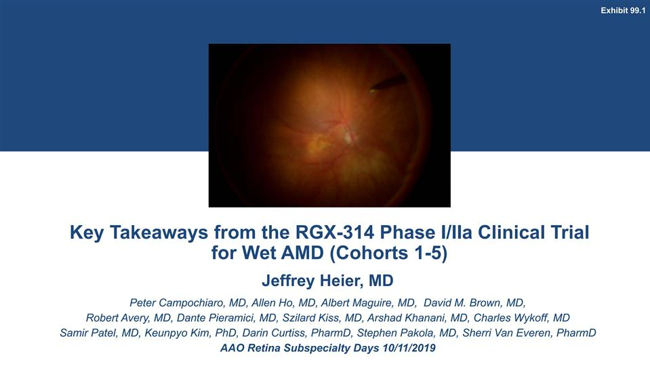

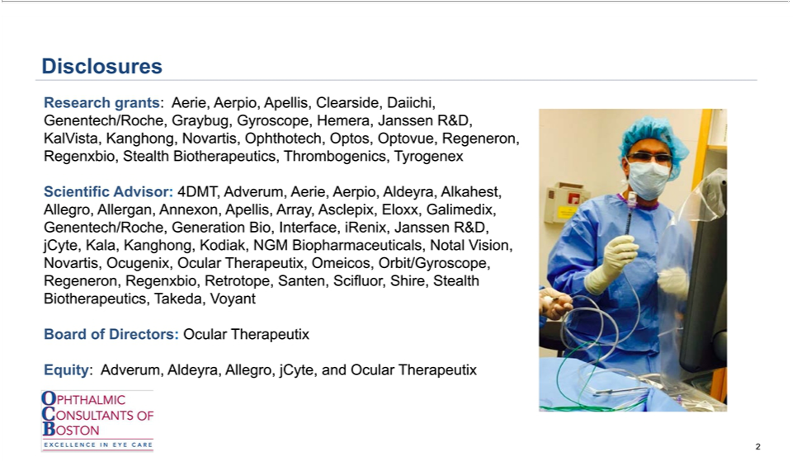

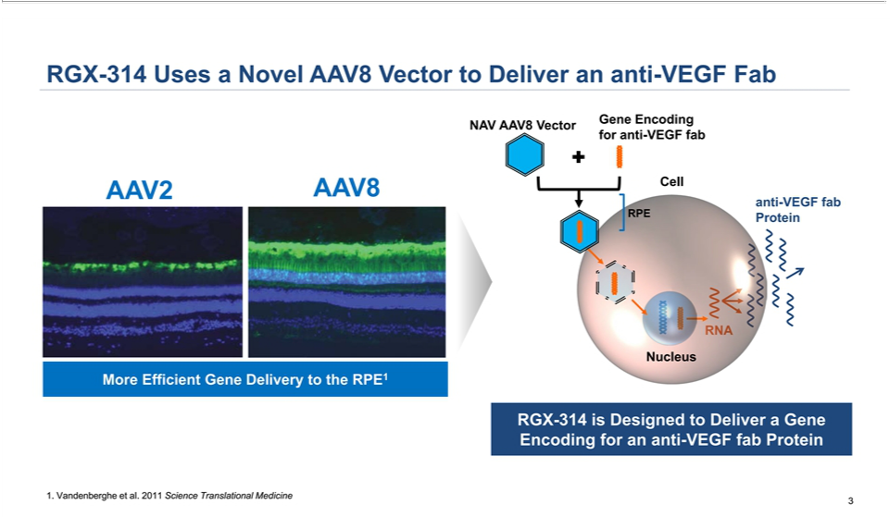

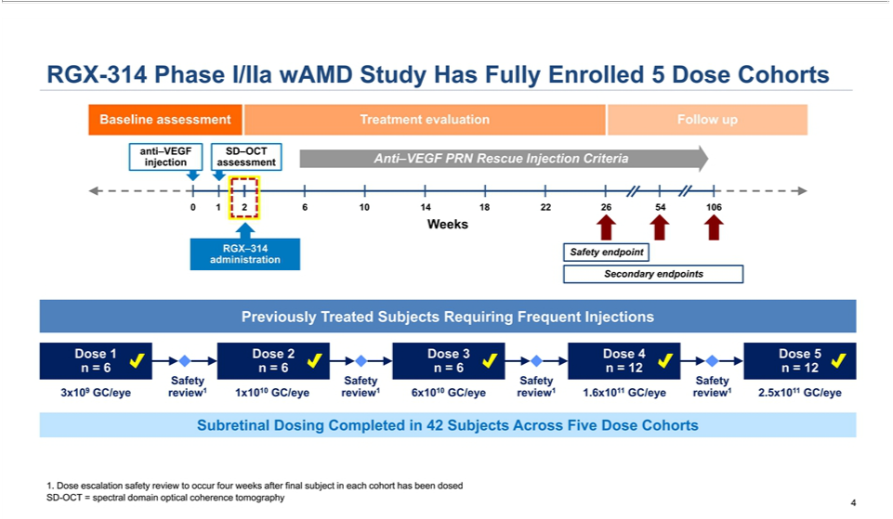

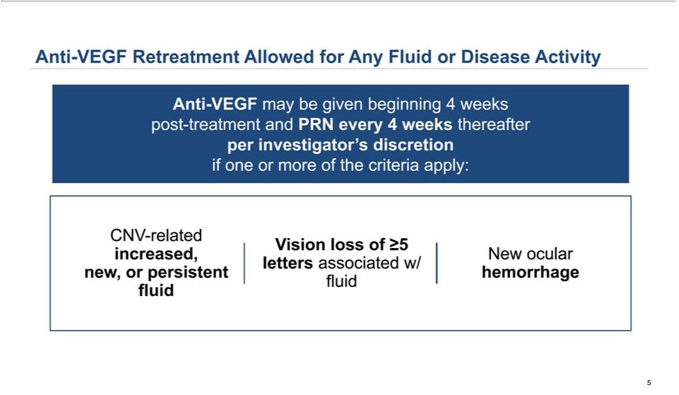

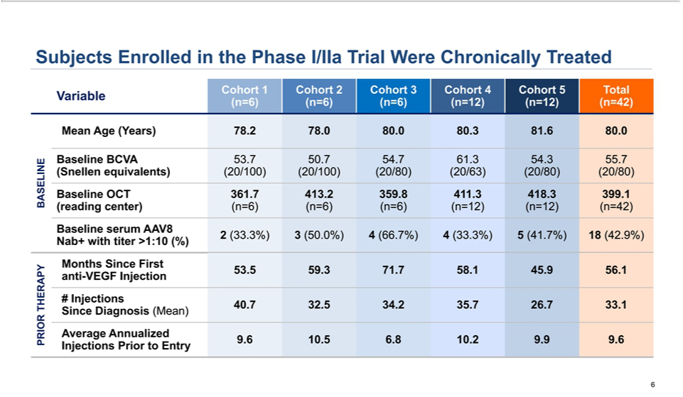

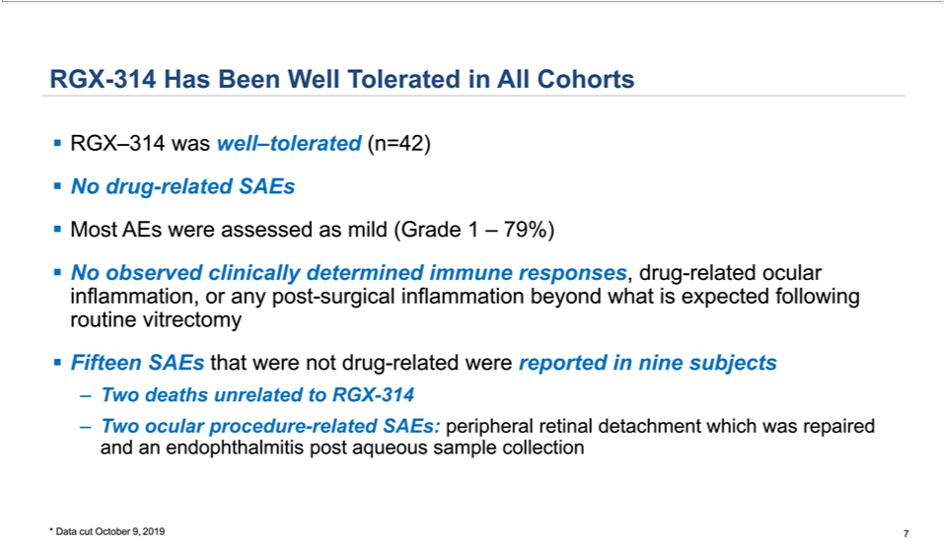

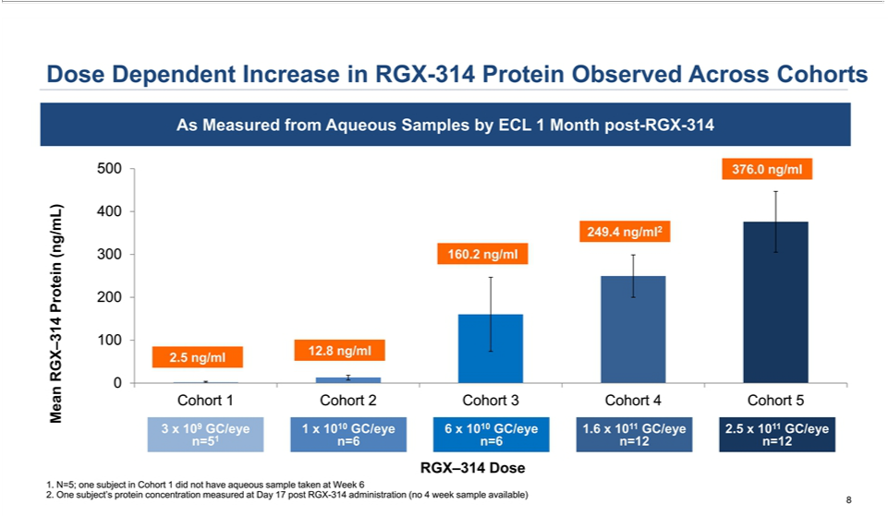

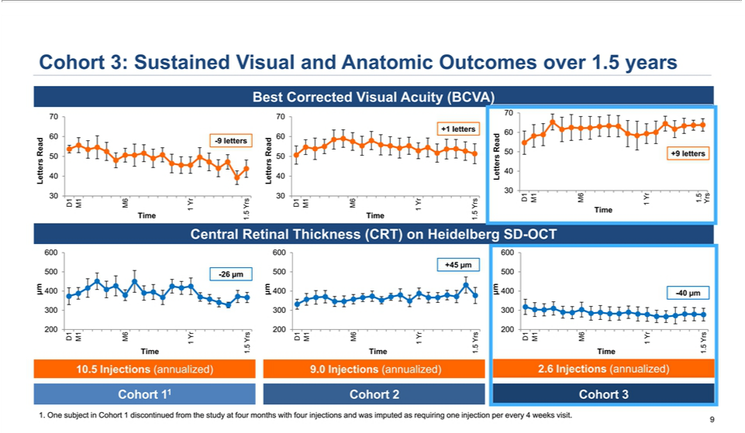

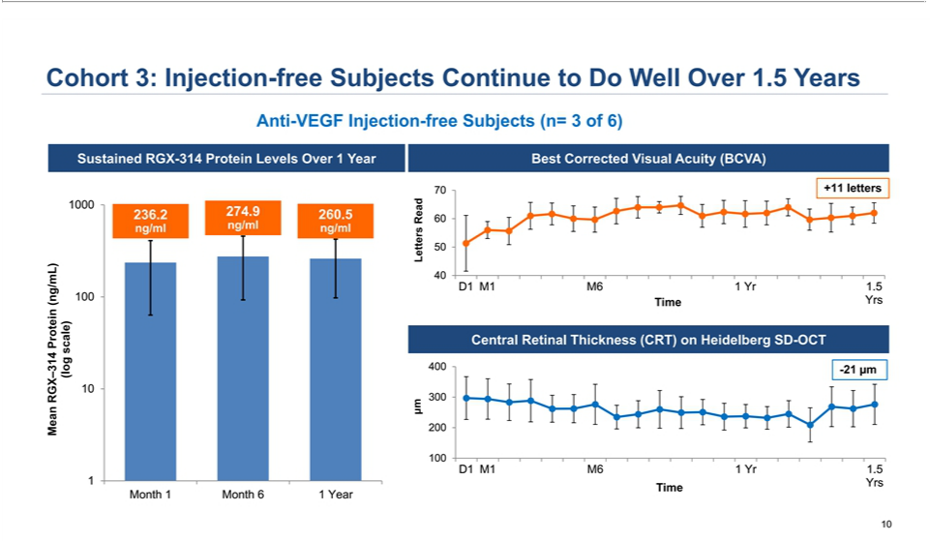

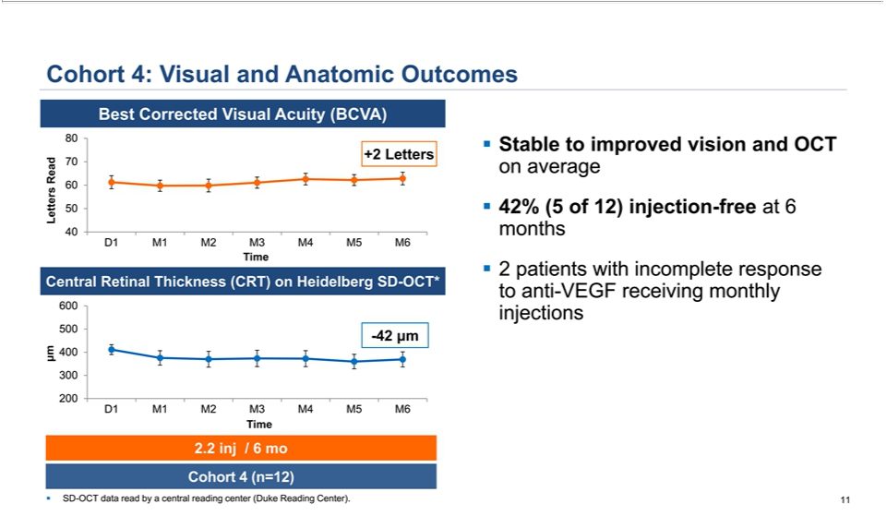

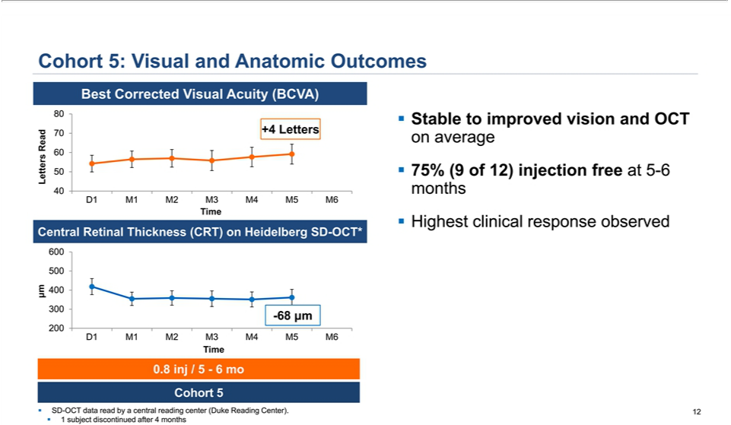

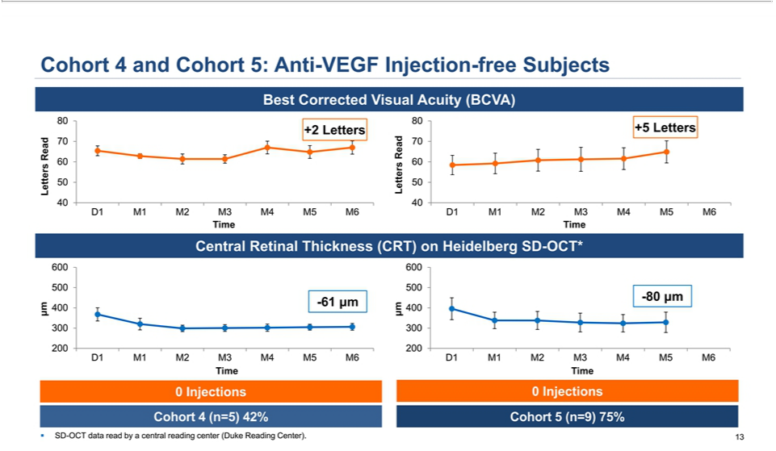

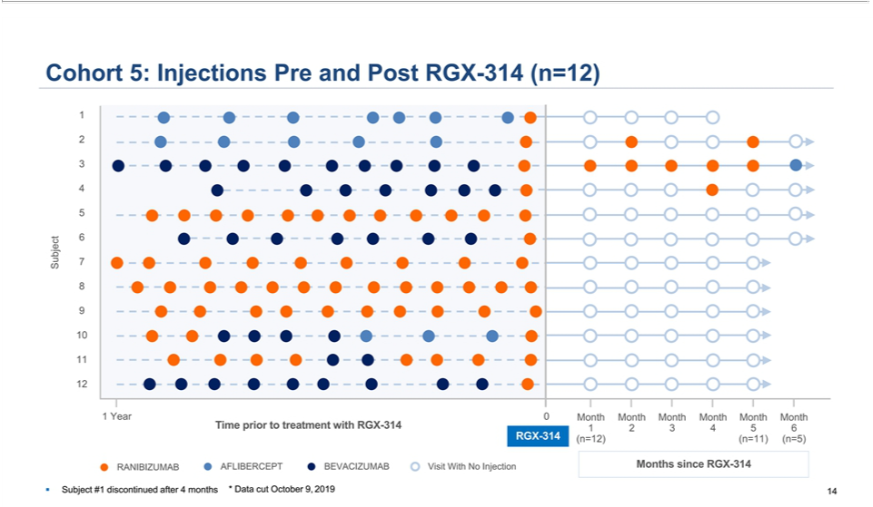

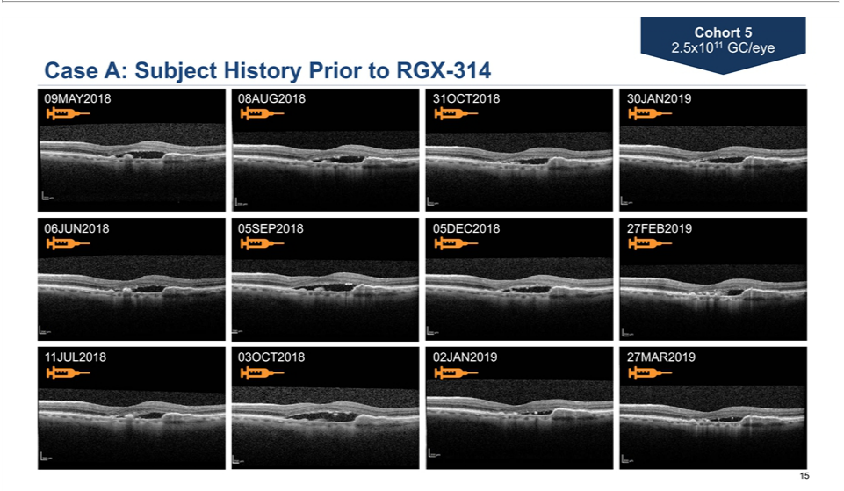

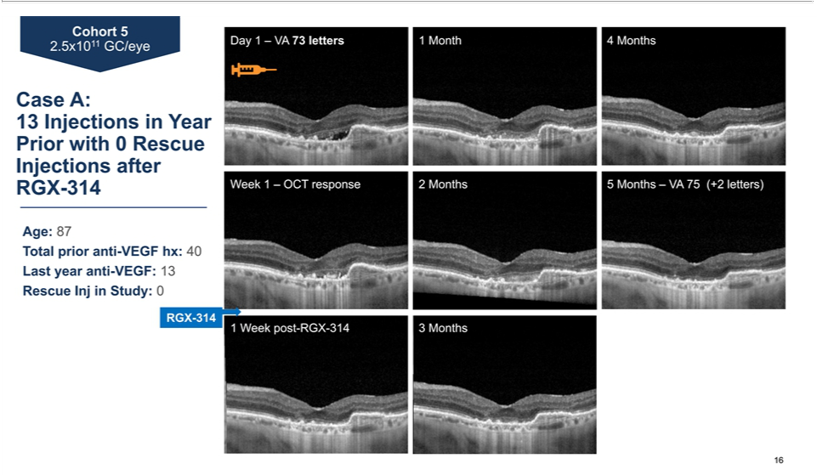

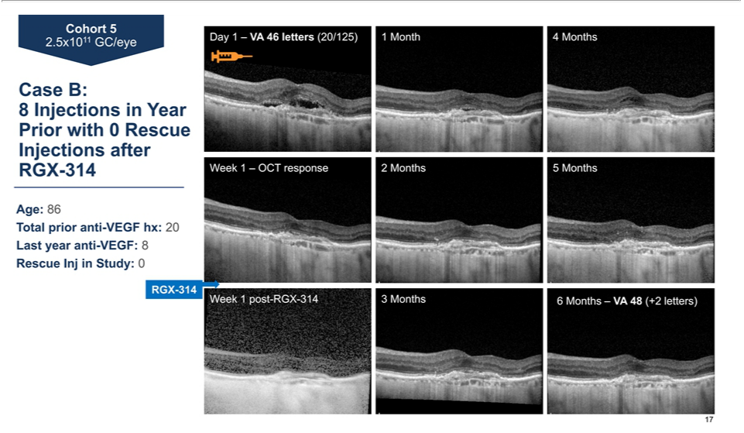

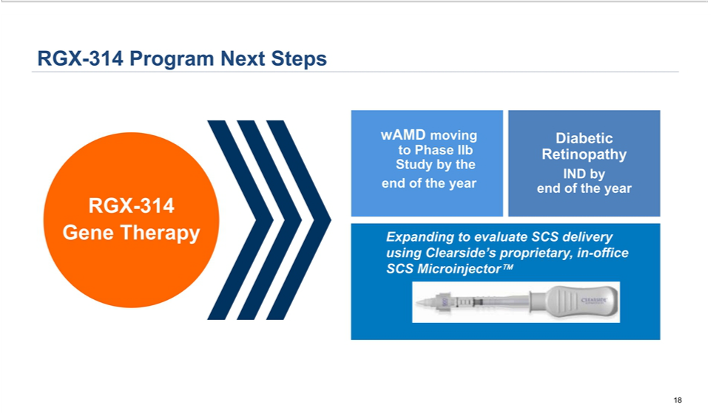

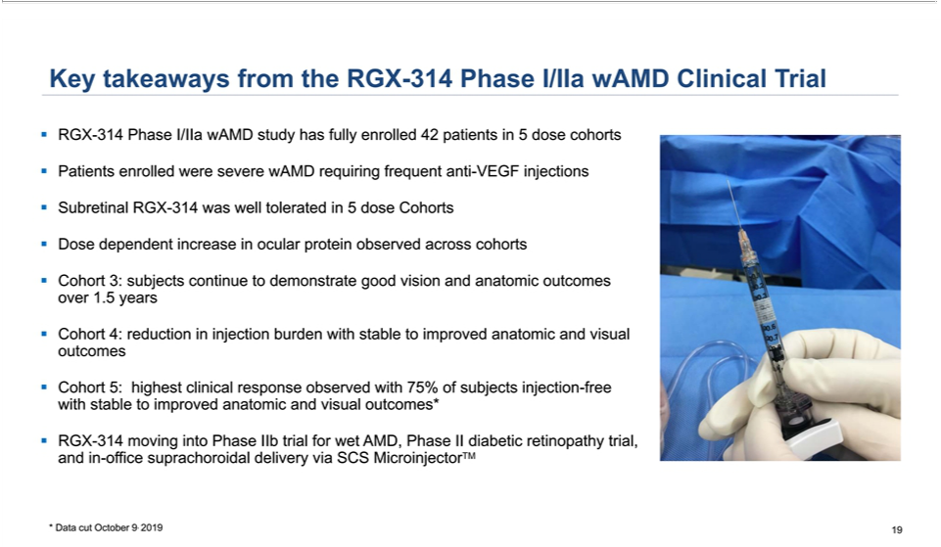

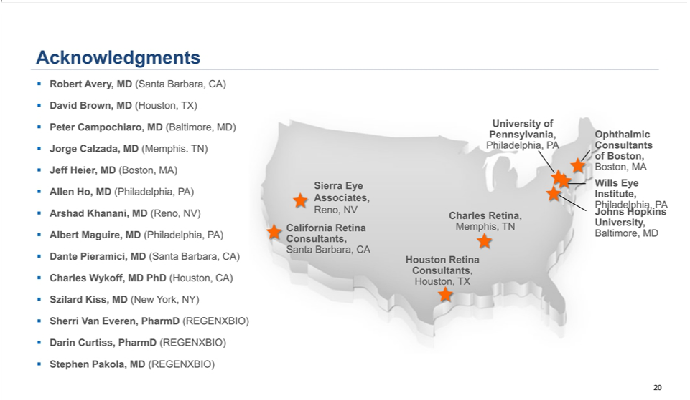

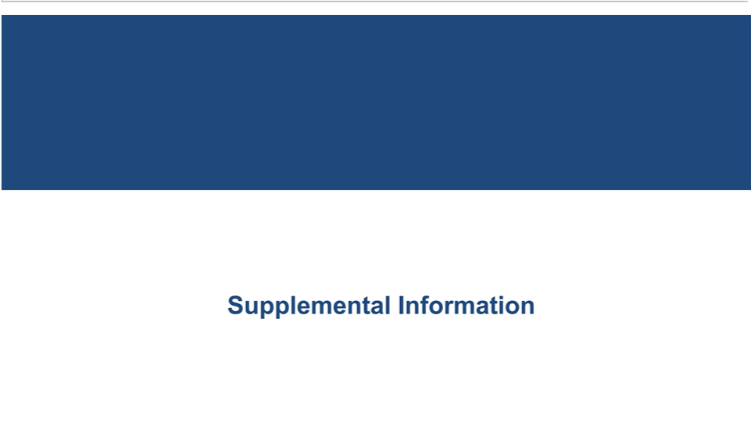

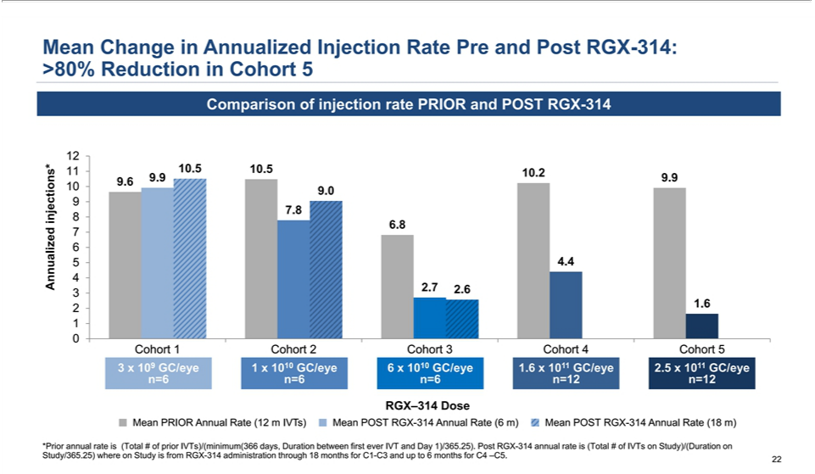

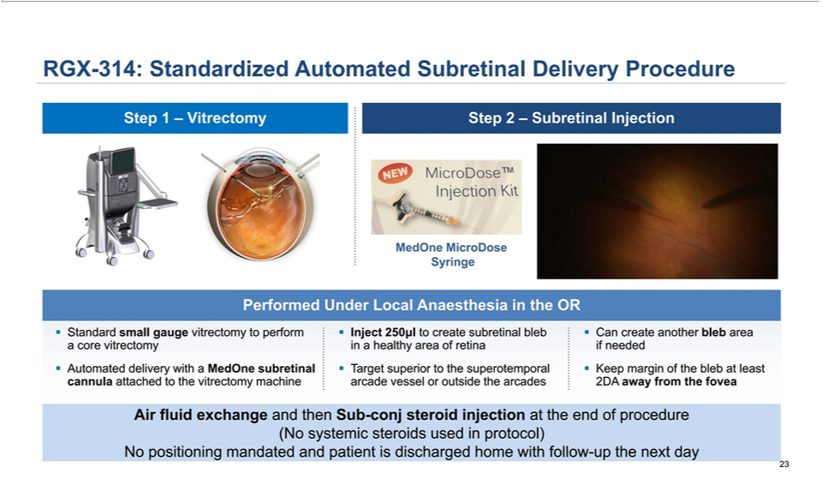

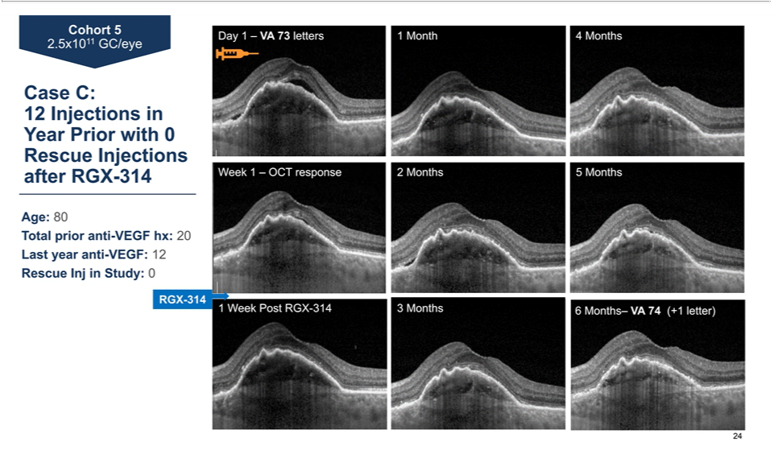

Exhibit 99.2


REGENXBIO Announces Additional Positive Interim Phase I/IIa Trial Update for RGX-314 for the Treatment of Wet AMD at the American Academy of Ophthalmology 2019 Annual Meeting

- RGX-314 continues to be well-tolerated

- 75% of subjects (9/12) in Cohort 5 remain free of anti-VEGF injections, with mean improvement in vision and retinal thickness

- Durable effects on vision and retinal thickness demonstrated over 1.5 years in Cohort 3; 50% of subjects (3/6) remain free of anti-VEGF injections at 1.5 years after RGX-314 administration

- Company on track to initiate a Phase IIb trial for wet AMD in late 2019

ROCKVILLE, Md., October 11, 2019 (PRNewswire) — REGENXBIO Inc. (Nasdaq: RGNX), a leading clinical-stage biotechnology company seeking to improve lives through the curative potential of gene therapy based on its proprietary NAV® Technology Platform, today announced interim data from the ongoing Phase I/IIa trial of RGX-314 for the treatment of wet age-related macular degeneration (wet AMD). The results were presented by Jeffrey S. Heier, M.D., Co-President and Director of Retina Research at Ophthalmic Consultants of Boston and primary investigator for the trial, in a podium presentation at the Retina Subspecialty Day program of the American Academy of Ophthalmology (AAO) 2019 Annual Meeting in San Francisco, CA.

“Today’s interim update from the RGX-314 Phase I/IIa dose escalation study further demonstrates the significant reduction in anti-VEGF treatment burden and encouraging improvement or maintenance of effects on vision and retinal thickness in the three higher dose cohorts,” said Dr. Heier. “These effects are especially important as subjects in this study had been previously treated with chronic and burdensome anti-VEGF injections over several years, highlighting the severity of their disease. Today’s results further support the potential of RGX-314 gene therapy to have meaningful and durable effects in patients following a one-time intervention.”

Detailed study findings, including those presented by Dr. Heier at AAO 2019, are available under the Presentations & Publications page in the Media section of the company’s website located at www.regenxbio.com.

Study Design and Safety

In the Phase I/IIa trial of RGX-314, 42 subjects with severe wet AMD requiring frequent anti-vascular endothelial growth factor (anti-VEGF) injections have been treated across five dose cohorts, with doses ranging from 3x109 GC/eye to 2.5x1011 GC/eye. Subjects were enrolled into all dose cohorts independent of their neutralizing antibody titers to AAV and did not receive prophylactic immune suppressive oral corticosteroid therapy before or after administration of RGX-314.

Subjects in the study are being assessed each month, with long-term follow-up continuing for 24 months. Assessments for the study include reduction in anti-VEGF intravitreal injections, change in vision measured by Best Corrected Visual Acuity (BCVA), change in central retinal thickness (CRT) measured by spectral domain optical coherence tomography (SD-OCT), and protein expression levels as measured from aqueous samples by electrochemiluminescence immunoassay (ECL).

As of October 9, 2019, RGX-314 continues to be well-tolerated across all cohorts, with no drug-related serious adverse events (SAEs) reported. Fifteen SAEs that were not related to RGX-314, including two ocular procedure-related SAEs, were reported in 9 subjects. There have been no reports of clinically-determined immune responses, drug-related ocular inflammation, or post-surgical inflammation beyond what is expected following routine vitrectomy.

Summary of Data for Cohorts 4 and 5

Today’s interim update includes data as of October 9, 2019 for Cohorts 4 and 5, which enrolled 12 subjects each, at doses of 1.6x1011 GC/eye and

2.5x1011 GC/eye, respectively. All 12 subjects in Cohort 4 reached 6 months of follow-up, and subjects in Cohort 5 reached 5 or 6 months of follow-up as of the data cut-off, with the exception of one subject who discontinued from the study at 4 months1.

Subjects in Cohort 5 on average had a meaningful reduction in anti-VEGF treatment burden, with 9 out of 12 (75%) subjects remaining anti-VEGF

injection-free as of the data cut-off. Across the 12 subjects, there was a mean of 0.8 injections through 5 or 6 months following administration of

RGX-314, a reduction of over 80% from the mean annualized injection rate during the 12 months prior to administration of RGX-314. Importantly,

subjects in Cohort 5 improved visual acuity and decreased retinal thickness, with a mean BCVA change of +4 letters and a mean change in CRT of

-68µm after one-time administration of RGX-314. The 9 subjects who were anti-VEGF injection-free after administration of RGX-314 showed a mean

BCVA improvement of +5 letters, and a mean improvement in CRT of -80µm.

Subjects in Cohort 4 on average also had a meaningful reduction in anti-VEGF treatment burden, with 5 out of 12 (42%) subjects receiving no anti-VEGF injections in 6 months following administration of RGX-314. Across the 12 subjects in the cohort, there was a mean of 2.2 injections over 6 months following administration of RGX-314, a reduction of over 50% from the mean annualized injection rate during the 12 months prior to administration of RGX-314. Subjects in Cohort 4 maintained visual acuity and decreased retinal thickness, with a mean BCVA change of +2 letters, and a mean change in CRT of -42 µm. The 5 subjects who did not receive anti-VEGF injections after administration of RGX-314 showed a mean BCVA change of +2 letters, and a mean improvement in CRT of -61µm.

Intraocular RGX-314 protein expression levels increased in a dose-dependent manner when measured at approximately one month after administration of RGX-314; the mean protein expression level in Cohort 4 was 249.4 ng/ml, and the mean protein expression level in Cohort 5 was 376.0 ng/ml.

Summary of Long-Term Data for Cohort 3

Subjects in Cohort 3 continue to demonstrate long-term reductions in anti-VEGF treatment burden over 1.5 years. Importantly, 3 out of 6 subjects (50%) continue to remain anti-VEGF injection-free at 1.5 years. The 6 subjects across the cohort demonstrated a mean annualized rate of 2.6 anti-VEGF injections following administration of RGX-314, a reduction of over 50% from the mean annualized injection rate during the 12 months prior administration of RGX-314.

Positive long-term efficacy signals were sustained through 1.5 years in Cohort 3, including a mean BCVA improvement of +9 letters and a mean change in CRT of -40 µm. Notably, in the three patients who have remained anti-VEGF injection free at 1.5 years, the increase from baseline BCVA was +11 letters and the mean change in CRT was -21 µm.

“Frequent anti-VEGF injections have been shown to reduce the risk of blindness in subjects with wet AMD, but real-world evidence shows that people lose vision over time due to non-compliance. The notable reduction in anti-VEGF treatments seen after a single administration of the highest dose of RGX-314 in Cohort 5 is particularly encouraging, given the severity of the disease and the high treatment burden for these enrolled subjects prior to administration of RGX-314,” said Steve Pakola, M.D., Chief Medical Officer of REGENXBIO. “We look forward to our anticipated start of the Phase IIb trial in subjects with wet AMD by the end of this year.”

About RGX-314

RGX-314 is being developed as a potential one-time treatment for wet age-related macular degeneration (wet AMD), diabetic retinopathy (DR), and other additional chronic retinal conditions treated with anti-VEGF. RGX-314 consists of the NAV AAV8 vector encoding an antibody fragment which inhibits VEGF, modifying the pathway for formation of new leaky blood vessels which lead to retinal fluid accumulation and vision loss.

About the Phase I/IIa Clinical Trial of RGX-314

RGX-314 is being evaluated in a Phase I/IIa, multi-center, open-label, multiple-cohort, dose-escalation study in adult subjects with wet AMD in the United States. The study includes subjects previously treated for wet AMD who are responsive to anti-VEGF therapy. The study is designed to evaluate five escalating doses of RGX-314, with six subjects in the first three dose cohorts and 12 subjects in the fourth and fifth dose cohorts. Subjects were enrolled into all dose cohorts independent of their neutralizing antibody titers to AAV and did not receive prophylactic immune suppressive oral corticosteroid therapy before or after administration of RGX-314. Secondary endpoints include visual acuity, retinal thickness on spectral domain optical coherence tomography (SD-OCT), ocular RGX-314 protein expression, and the need for additional anti-VEGF therapy. Following completion of the primary study period, subjects enter a follow-up period and will continue to be assessed until week 106 for long-term safety and durability of effect.

About Wet AMD

Wet AMD is characterized by loss of vision due to new, leaky blood vessel formation in the retina. Wet AMD is a significant cause of vision loss in the United States, Europe and Japan, with up to 2 million people living with wet AMD in these geographies alone. Current anti-VEGF therapies have significantly changed the landscape for treatment of wet AMD, becoming the standard of care due to their ability to prevent progression of vision loss in the majority of patients. These therapies, however, require life-long intraocular injections, typically repeated every four to 12 weeks in frequency, to maintain efficacy. Due to the burden of treatment, patients often experience a decline in vision with reduced frequency of treatment over time.

About REGENXBIO Inc.

REGENXBIO is a leading clinical-stage biotechnology company seeking to improve lives through the curative potential of gene therapy. REGENXBIO’s NAV Technology Platform, a proprietary adeno-associated virus (AAV) gene delivery platform, consists of exclusive rights to more than 100 novel AAV vectors, including AAV7, AAV8, AAV9 and AAVrh10. REGENXBIO and its third-party NAV Technology Platform Licensees are applying the NAV Technology Platform in the development of a broad pipeline of candidates in multiple therapeutic areas.

Forward-Looking Statements

This press release includes “forward-looking statements,” within the meaning of Section 27A of the Securities Act of 1933, as amended, and Section 21E of the Securities Exchange Act of 1934, as amended. These statements express a belief, expectation or intention and are generally accompanied by words that convey projected future events or outcomes such as “believe,” “may,” “will,” “estimate,” “continue,” “anticipate,” “design,” “intend,” “expect,” “could,” “plan,” “potential,” “predict,” “seek,” “should,” “would” or by variations of such words or by similar expressions. The forward-looking statements include statements relating to, among other things, REGENXBIO’s future operations and clinical trials. REGENXBIO has based these forward-looking statements on its current expectations and assumptions and analyses made by REGENXBIO in light of its experience and its perception of historical trends, current conditions and expected future developments, as well as other factors REGENXBIO believes are appropriate under the circumstances. However, whether actual results and developments will conform with REGENXBIO’s expectations and predictions is subject to a number of risks and uncertainties, including the timing of enrollment, commencement and completion and the success of clinical trials conducted by REGENXBIO, its licensees and its partners, the timing of commencement and completion and the success of preclinical studies conducted by REGENXBIO and its development partners, the timely development and launch of new products, the ability to obtain and maintain regulatory approval of product candidates, the ability to obtain and maintain intellectual property protection for product candidates and technology, trends and challenges in the business and markets in which REGENXBIO

operates, the size and growth of potential markets for product candidates and the ability to serve those markets, the rate and degree of acceptance of product candidates, and other factors, many of which are beyond the control of REGENXBIO. Refer to the “Risk Factors” and “Management’s Discussion and Analysis of Financial Condition and Results of Operations” sections of REGENXBIO’s Annual Report on Form 10-K for the year ended December 31, 2018, and comparable “risk factors” sections of REGENXBIO’s Quarterly Reports on Form 10-Q and other filings, which have been filed with the U.S. Securities and Exchange Commission (SEC) and are available on the SEC’s website at www.sec.gov. All of the forward-looking statements made in this press release are expressly qualified by the cautionary statements contained or referred to herein. The actual results or developments anticipated may not be realized or, even if substantially realized, they may not have the expected consequences to or effects on REGENXBIO or its businesses or operations. Such statements are not guarantees of future performance and actual results or developments may differ materially from those projected in the forward-looking statements. Readers are cautioned not to rely too heavily on the forward-looking statements contained in this press release. These forward-looking statements speak only as of the date of this press release. REGENXBIO does not undertake any obligation, and specifically declines any obligation, to update or revise any forward-looking statements, whether as a result of new information, future events or otherwise.

- This subject died 4.5 months after the administration of RGX-314 as a result of the subject’s underlying disease, which was assessed to be unrelated to RGX-314. At the time of the death, the subject was free of anti-VEGF injections.

###

Contacts:

Tricia Truehart

Investor Relations and Corporate Communications

347-926-7709

ttruehart@regenxbio.com

Investors:

Heather Savelle, 212-600-1902

heather@argotpartners.com

Media:

David Rosen, 212-600-1902

david.rosen@argotpartners.com

